# *Fop home task 5*

## Name: Muhammad Usman Bhutto

## Roll no: 453891

**Section: B**

*Home task 1:*

#include<iostream>

using namespace std;

int main()

{

int num1,num2,i;

cout<<"enter two numbers for Lcm:";

cin>>num1>>num2;

for(i=num1;i<=num1*num2;i++)

{

if(i%num1==0 && i%num2==0)

{

cout << "the Lcm of" << num1 << "and" << num2 << "is" << i << endl;

break;

}

}

return 0;}

*Output:*

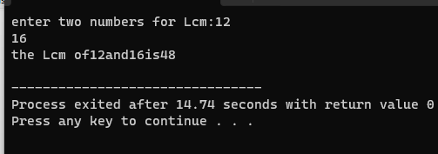

*Home task 2:*

#include <iostream>

using namespace std;

int main() {

int firstTerm, commonDifference, numberOfTerms;

double sum = 0;

cout << "Enter the first term: ";

cin >> firstTerm;

cout << "Enter the common difference: ";

cin >> commonDifference;

cout << "Enter the number of terms: ";

cin >> numberOfTerms;

for (int i = 0; i < numberOfTerms; i++) {

sum += firstTerm + i * commonDifference;

}

cout << "The sum of the arithmetic progression is: " << sum <<endl;

return 0;

}

*Output:*

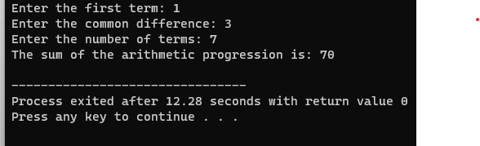

*Home task 3:*

#include<iostream>

using namespace std;

int main()

{

int i, j, rowNum, space;

cout<<"Enter the Number of Rows: ";

cin>>rowNum;

space = rowNum-1;

for(i=1; i<=rowNum; i++)

{

for(j=1; j<=space; j++)

cout<<" ";

space--;

for(j=1; j<=(2*i-1); j++)

cout<<"*";

cout<<endl;

}

space = 1;

for(i=1; i<=(rowNum-1); i++)

{

for(j=1; j<=space; j++)

cout<<" ";

space++;

for(j=1; j<=(2*(rowNum-i)-1); j++)

cout<<"*";

cout<<endl;

}

cout<<endl;

return 0;

}

*Output:*

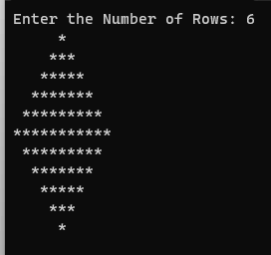

*Home task 4:*

#include<iostream>

using namespace std;

void des (int n);

int main()

{

int num;

cout<<"enter any decimal number:";

cin>>num;

cout<<"binary converted number:";

des(num);

}

void des (int n)

{

if(n==0||n==1)

{

cout<<n;

return;

}

des(n/2);

des(n%2);

}

*Output:*

